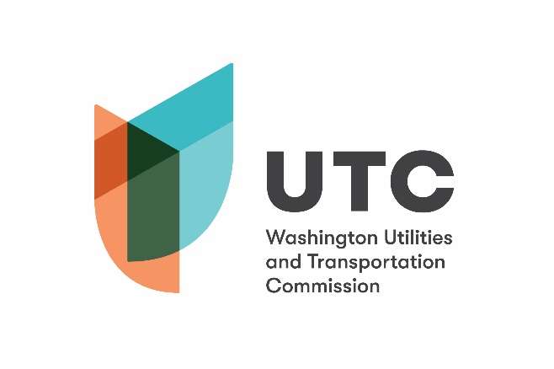 | 621 Woodland Square Loop SE  Lacey, WA 98503  PO Box 47250  Olympia, WA 98504-7250  (360) 664-1119 or (360) 664-1262  Web: www.utc.wa.gov

GRADE CROSSING PROTECTIVE FUND
2021 – 2023 GRANT APPLICATION
OPEN CALL FOR PROJECTS

The Washington Utilities and Transportation Commission (UTC), through the Grade Crossing Protective Fund (GCPF), provides grants for projects that eliminate or reduce public safety hazards at railroad crossings and along railroad rights-of-way in Washington State. Any public, private or non-profit entity may submit an application for a GCPF grant.

To apply for a grant to eliminate or reduce a public safety hazard at a railroad crossing or along a railroad right-of-way, complete the following information and submit it and any attachments to the UTC. If you are proposing a change to the warning devices at a public railroad crossing, you must use the Petition to Modify Warning Devices – GCPF, and not this form.

Please be sure to complete the entire form. Incomplete or missing information will delay the grant review process.

Applicant Information

Applicant Name:
Signature:
Organization:
Address:
Phone:
Email:

Project Information

Attach additional sheets as necessary that provide the following:

- A detailed summary of the hazard being addressed. Include any information about accidents or incidents at the site and photographs, drawings or other materials that support the application.

- A detailed summary of the proposed project and how it will eliminate or mitigate the hazard. Include any drawings or construction plans for the proposed project.

- A list of all other companies, organizations, state agencies or local governments that may be involved in implementing this proposal, and the contact name, address, email, and phone number for each (if known).
- A cost estimate, including:
  - An itemized list of the total costs of the project.
  - Names of parties contributing to the project, including the applicant and the amount each is contributing.

- The name of the party responsible for long-term maintenance, such as repair of fencing.

- An estimated timeline of the project.

- A description of how the project’s success would be measured.

- A description of the applicant’s experience in grant management or successfully completing grant projects of this nature, including years of experience, types of projects completed and project cost/scope.

- Any other information the applicant believes would be useful to the UTC in evaluating the project.

Railroad Consent

If the applicant is not the railroad owning the crossing or the tracks, the applicant must submit the attached Railroad Consent form completed and signed by the railroad owning the crossing or tracks.

Submitting the Application

After completing the application, please send the original to:
Washington Utilities and Transportation Commission
Attention: Grade Crossing Protective Fund
621 Woodland Square Loop SE
Lacey, WA 98503
PO Box 47250
Olympia, WA 98504-7250

A signed application may be filed electronically at records@utc.wa.gov. When filing electronically, please specify “Grade Crossing Protective Fund” in the subject line.

Assistance

For questions or assistance, please contact:
- Mike Turcott at (360) 664-1119 or mike.turcott@utc.wa.gov
- Betty Young at (360) 292-5470 or betty.young@utc.wa.gov

Railroad Consent

The undersigned represents the Railroad Company in the accompanying GCPF application.

We have reviewed the application and are satisfied that the conditions are the same as described by the applicant in this matter. We agree to allow construction, modification or demolition on a railroad right-of-way as described in the application.

Printed name of Railroad Representative

Signature of Railroad Representative

Title

Name of Railroad

Mailing Address of Railroad

Telephone Number

Email

Date:

