Issue Brief 4

Washington State’s Energy System

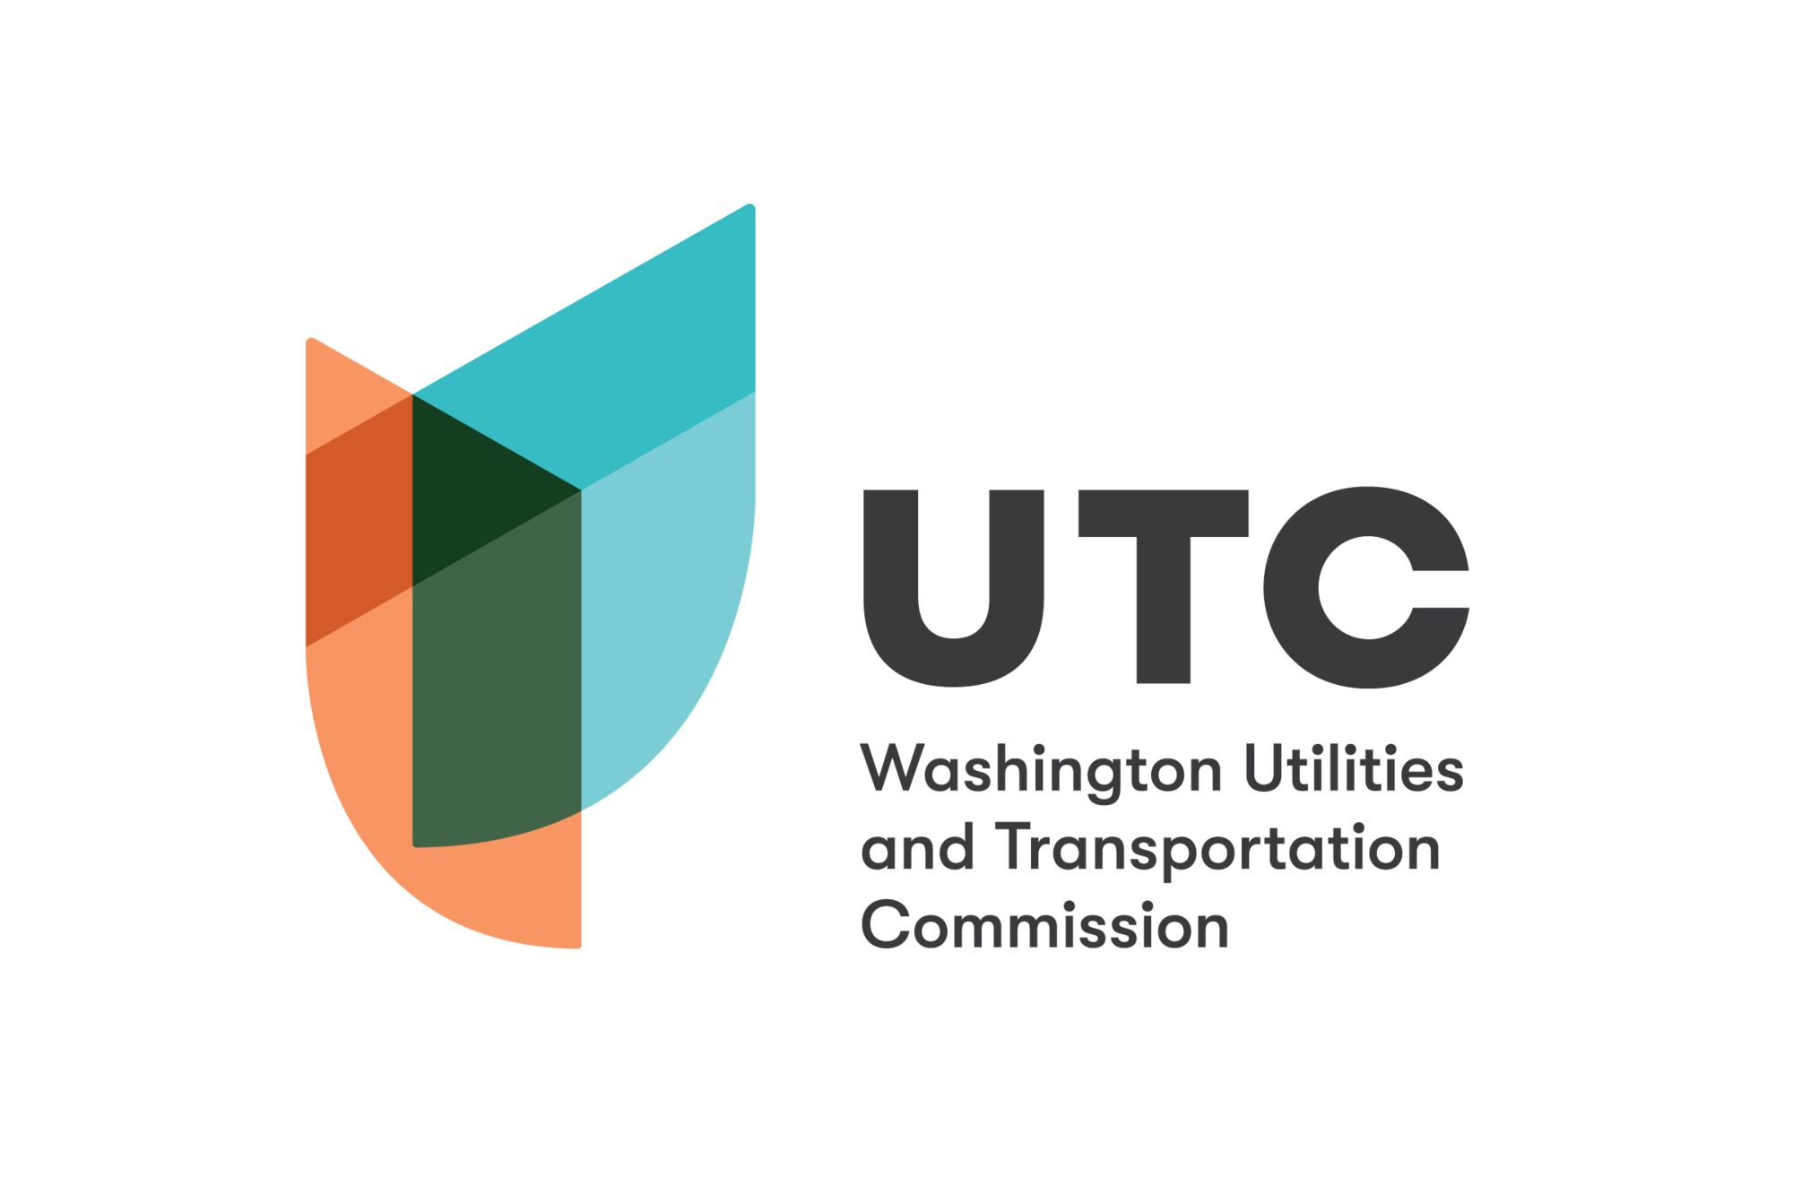

Washington’s Energy System
Washington’s energy system is unique. The state is the country’s leading producer of hydroelectricity, with nearly two thirds of the state’s electricity provided by hydropower (mainly from the Federal Columbia River power system). It also has relatively low energy demand, with per capita consumption among the bottom third of states. The state is a net exporter of electricity, producing 116.8 TWh, or around 3% of total electricity in the U.S., in 2020. Washington is a net importer of other forms of energy, consuming roughly two and a half times the amount of energy it produces (including natural gas, oil, and other fossil fuel sources).

Energy and Electricity Demand and Prices
Measured in millions of kilowatt hours, electricity consumption in Washington in 2021 was highest in the residential sector (43.5%), followed by the commercial sector (32.1%) and industrial (24.1%) sector. Transportation electricity consumption was comparatively minimal, although it is increasing. Electricity prices in Washington are among the lowest in the nation, with an average retail price of 8.78 cents per kWh in 2021, an increase from 8.33 cents/kWh in 2020. Residential prices for gas were $10.97 per thousand cubic feet in 2020, although rate changes since October 2021 have increased average prices.

Electricity Generation, Consumption, and Transmission
Electricity generating resources within Washington state include one coal-fired power plant (in Centralia, WA and slated to be closed in 2025), four petroleum (distillate fuel oil) power plants, 21 natural gas-fired power plants, one nuclear power plant, 74 hydroelectric power plants, and 32 renewable (non-hydroelectric) power plants. In 2020, nearly 30% of natural gas consumed in the state was used for electricity production, fueling approximately 12% of electricity generation (measured in thousands of megawatt hours), the second highest fuel source after hydropower. Electricity is used for home heating in 56.3% of homes, above the national average of 39%. 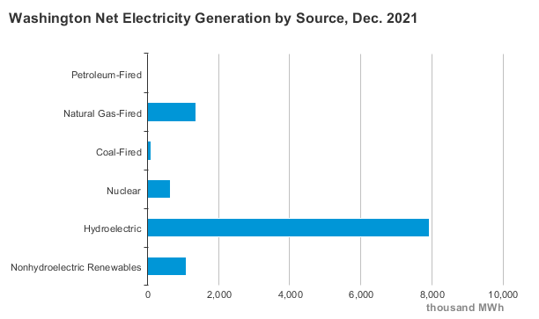

Figure 1. Washington’s net electricity generation by source, December 2021, in thousands of MWh (Data source: U.S. Energy Information Administration).
Washington does not consume all of the power generated within its borders; excess power is shared via the Western Interconnection regional grid with 14 other Western states, the Canadian provinces of British Columbia and Alberta, and the northern part of Baja California, Mexico. More than 4,500 miles of high-voltage (>230 kV) and 3,300 miles of low-voltage (<230 kV) transmission lines cross the state, bringing power to rural and urban areas from power plants and hydroelectric facilities in the state’s interior, as well as out of the state to other markets.

Natural Gas Consumption and Transmission
In 2020, natural gas consumption in Washington totaled 255 billion cubic feet (1% of the U.S. total). Washington has less natural gas use per capita than all but four other states and the District of Columbia. More than one third of households (34.2%) rely on natural gas to heat their homes in the winter, lower than the nationwide average of 47.6%. Industrial sector use of natural gas accounted for 25% of total demand in 2019, while the commercial sector accounted for 18%. Compressed natural gas as a transportation fuel accounts for less than 0.1% of natural gas consumption.
Natural gas largely enters the state from Canada, either directly or through the state of Idaho. More than 9,500 miles of interstate gas pipelines cross the state, mainly along the I-5 Corridor between Canada and the border with Oregon, and in the state’s East and Southeast regions. Only one third of natural gas that enters into Washington stays in the state; almost two-thirds continue south to Oregon and California. Thirty six pipeline operators maintain over 45,000 miles of pipelines carrying natural gas, gasoline, and jet fuel, including interstate pipelines operating at very high pressure.

Utilities
Washington has a variety of utility types serving electricity and natural gas customers, and often both. Dozens of municipally-owned utilities, consumer-owned utilities (electricity cooperatives), and public utility districts (PUDs) serve Washingtonians in addition to five investor-owned utilities: PacifiCorp, Cascade Natural Gas, NW Natural, Avista Utilities, and Puget Sound Energy. In 2019, investor-owned utilities provided 35% (32.9 million MWh) of electricity sold in Washington state.
PacifiCorp provides electricity only, while Cascade Natural Gas Corporation and NW Natural provide natural gas only; Avista Utilities and Puget Sound Energy provide both. According to the Washington State Department of Commerce, the average emissions rate (metric tons of CO₂e per MWh) for electricity generated by PacificCorp (0.547 mt/MWh), Puget Sound Energy (0.428), and Avista (0.404) ranked among the highest emissions rates for all electric utilities (investor-owned and otherwise) operating in Washington State in 2020.

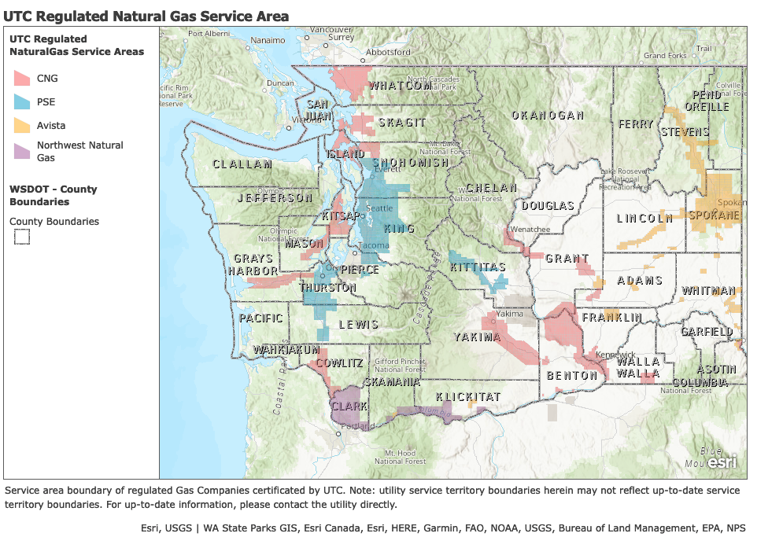

Figure 9. Service areas of Washington’s investor-owned natural gas utilities, with county outlines for reference (Source: Washington Utilities and Transportation Commission).

Sources
- U.S. Census Bureau. B25040 Census Bureau Table [data set], accessed June 20, 2022, https://data.census.gov/cedsci/table?q=Table%20B25040&g=0100000US_0400000US53&tid=ACSDT5Y2020.B25040.
- U.S. Department of Energy, Office of Electricity Delivery and Energy Reliability, “State of Washington Energy Sector Risk Profile”, 2020, https://www.energy.gov/sites/prod/files/2016/09/f33/WA_Energy%20Sector%20Risk%20Profile.pdf.
- U.S. Energy Information Administration, “Annual Electric Power Industry Report, Form EIA-861 Detailed Data Files,” accessed July 20, 2022, https://www.eia.gov/electricity/data/eia861/.
- U.S. Energy Information Administration, “Electricity Data Browser - Average Retail Price of Electricity”, accessed June 20, 2022, https://www.eia.gov/electricity/data/browser/#/topic/7?agg=0,1&geo=g00000000001&endsec=vg.
- U.S. Energy Information Administration, “Electricity Data Browser - Net Generation for Washington, All Sectors, Annual”, accessed June 20, 2022, https://www.eia.gov/electricity/data/browser/#/topic/0?agg=2,0,1&fuel=vtvv&geo=000000000001&sec=g.
- U.S. Energy Information Administration, “Electricity Data Browser - Retail Sales of Electricity, Washington, Annual”, accessed June 20, 2022, https://www.eia.gov/electricity/data/browser/#/topic/5?agg=0,1&geo=g00000000001&endsec=vg.
- U.S. Energy Information Administration, “Washington International and Interstate Movements of Natural Gas by State”, accessed June 20, 2022, https://www.eia.gov/dnav/ng/ng_move_ist_a2dcu_SWA_a.htm.
- U.S. Energy Information Administration, “Washington Natural Gas Prices”, accessed June 20, 2022, https://www.eia.gov/dnav/ng/ng_pri_sum_dcu_SWA_m.htm.
- U.S. Energy Information Administration, “Washington - State Energy Profile Analysis”, accessed March 28, 2022, https://www.eia.gov/state/analysis.php?sid=WA#114,
- Washington Utilities and Transportation Commission, “Pipeline Safety”, accessed June 20, 2022, https://www.utc.wa.gov/public-safety/pipeline-safety.
- Washington State Department of Commerce, “Washington Electric Utilities Fuel Mix Disclosure”, accessed March 8, 2022, https://www.commerce.wa.gov/growing-the-economy/energy/fuel-mix-disclosure/.
- Washington Utilities and Transportation Commission, “Rate Changes for Washington Natural Gas Customers Start Nov. 1”, accessed June 20, 2022, https://www.utc.wa.gov/news/2021/rate-changes-washington-natural-gas-customers-start-nov-1.
- Western Electricity Coordinating Council, “About WECC”, accessed June 20, 2022, https://www.wecc.org:443/Pages/AboutWECC.aspx.

